Day 5 - 30th May 2025

Task 1: Create a Directory with the Name Linux Practice.

mkdir LinuxPractice

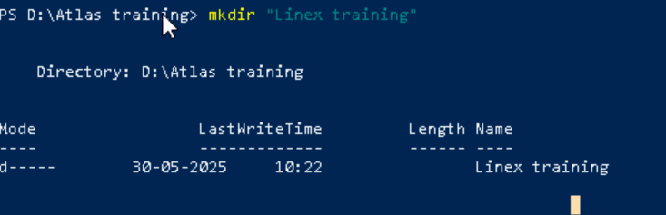

Task2: Change to the directory

 cd .\LinuxPractice\

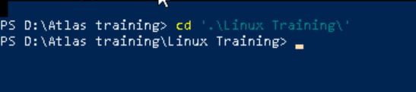

Task 3: Create a file names TestFile1.txt and add the content to it.

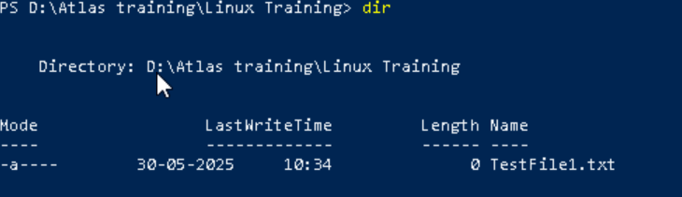

Task 4: Create a Folder named Dummy and try to delete it.

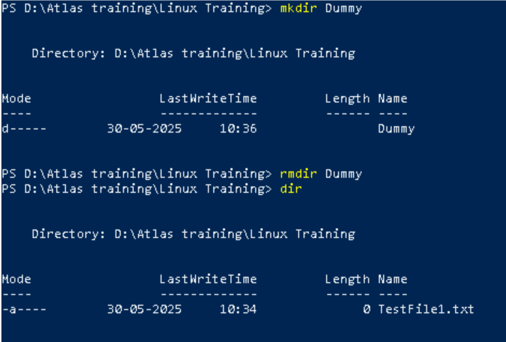

Task 5: Plz check the working directory (Hint : pwd)

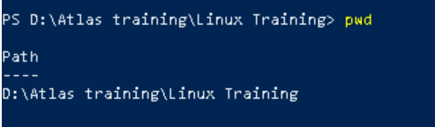

Task 6:  How do you check all the files and directories in the directory you are in?

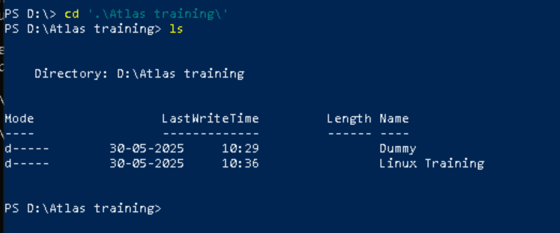

Task 7:

Create five files named TestFile2.txt.. TestFile3.txt… and so on till TestFile6.txt

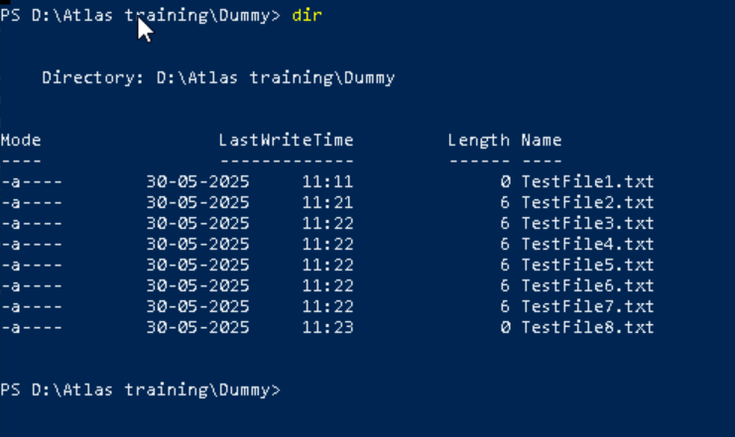

Task 8: Copy all files from Dir 1 ti Dir 2

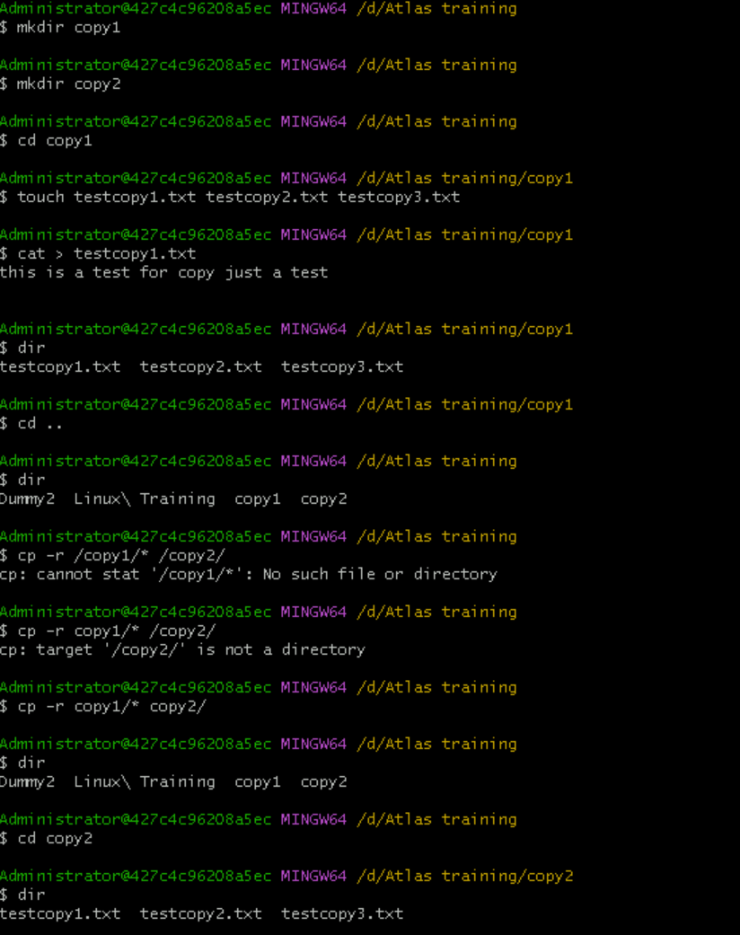

Task 9: Move all files from Dir 2 to Dir 3 (finally ur Dir 2 should be empty)

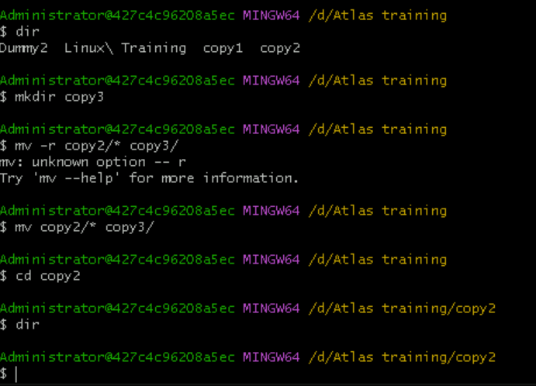

Task 10: Can you plz show me the diff between **rm** and **rmdir** commands with screen shots ?

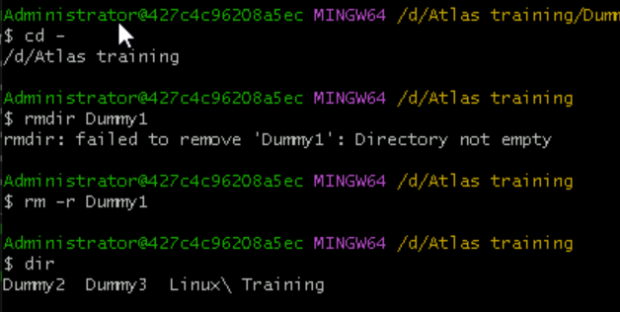

Task 11: Now use specifically use cat command to create a file

And add the dummy text of 2 to 3 paragraphs from the above link Lorem Ipsum.

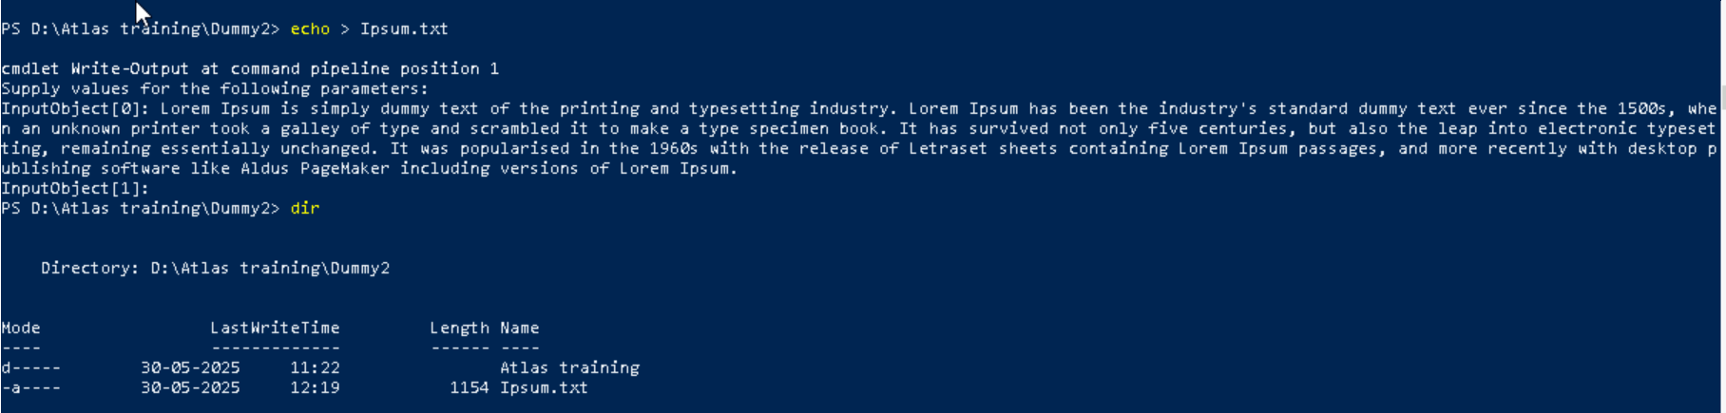

Task 12: How to get only the top part of your file..

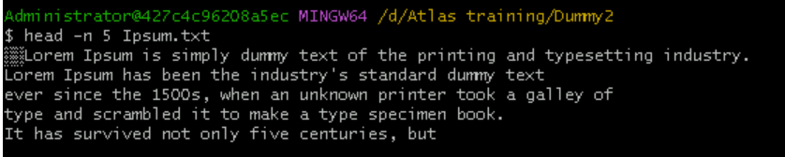

Hint: use head

Task 13: How to get only the last part of your file

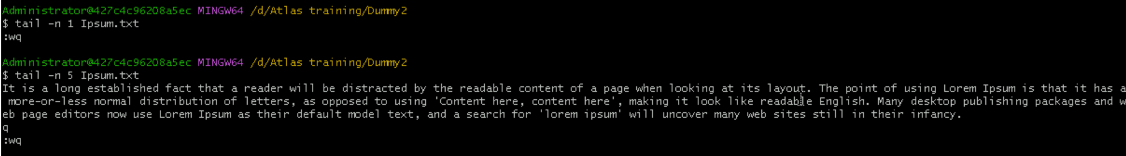

Hint: use tail

Task 14: Plz add dummy text of 5 to 6 pages in to the same file

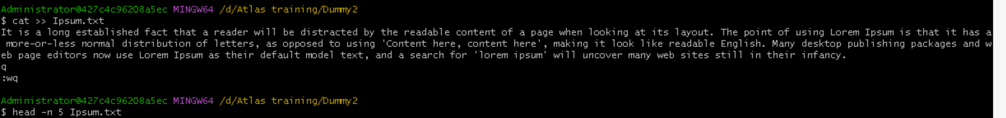

Now show the file in page by page

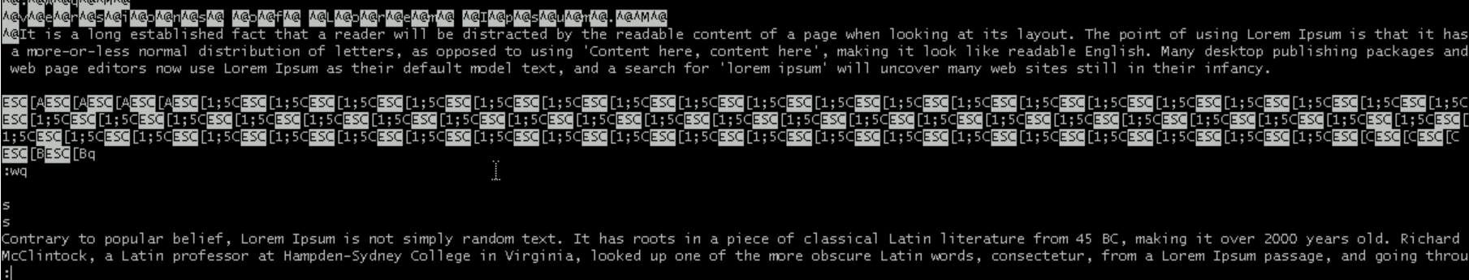

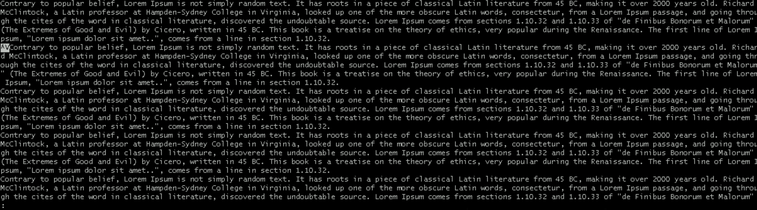

Hint : use less command

Task 15:

Use more command on the above file and find out the diff between less command and more command.

What is e in echo command..?

The e in the echo command is an option that enables the interpretation of backslash escape sequences. These sequences allow you to insert special characters and formatting into the output.

Task 16: Can you use echo command with -e and see the diff.. Also take a ss and paste .

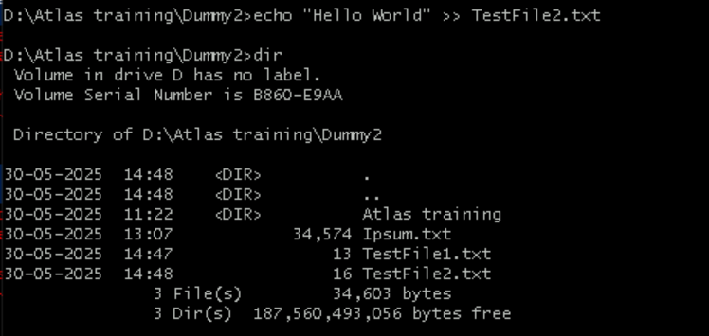

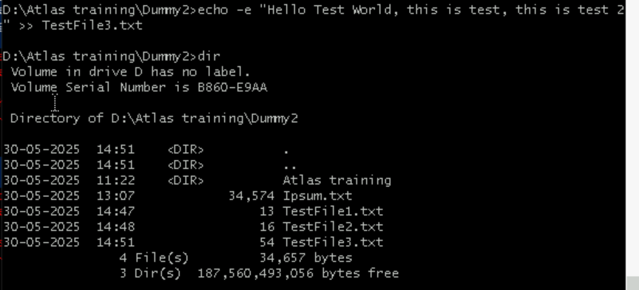

Task 17:

What is diff between ls and ls -l command .. ss plz

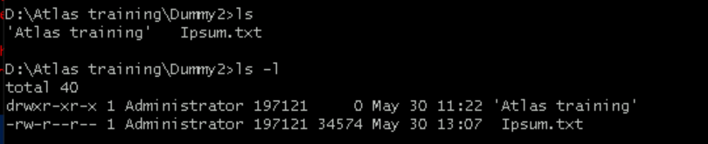

Task 18: Create  a file using **touch** command , **cat** command and **echo** command and take ss (screen shot)..

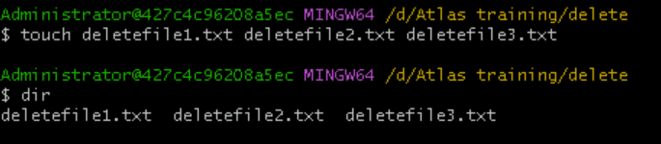

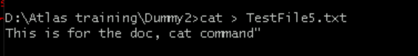



Touch command: this command will create a file without asking to enter text.

Cat command: with contact we can create files and also we can contact files

Echo command: this command enables the user to enter the text in double quotes and redirect it to the file.

Task 19: Can you guys try to display the calendar by using a command..

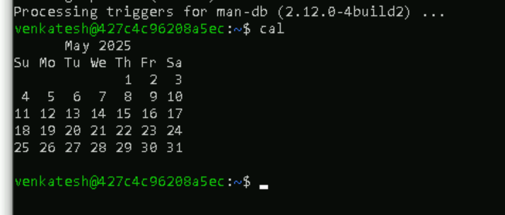

Task 20: Can you go back to 1 directory .. at a time  whats the command

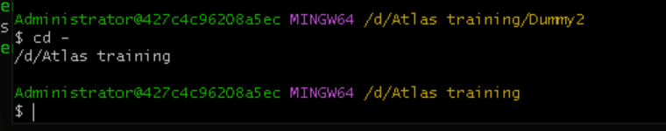

Task 21: How to know whose user u are working on ?

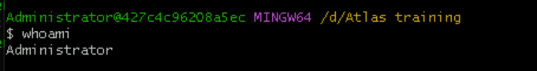

Task 22: Try to find out who is peeping into your system..

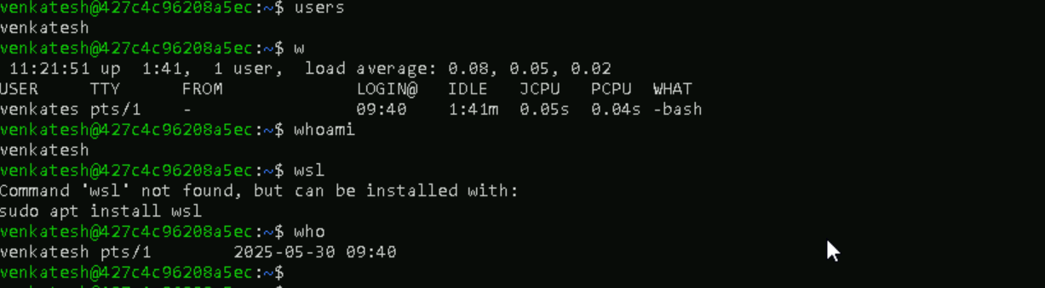

Task 23: Can you guys try to check how much disk space is consumed..

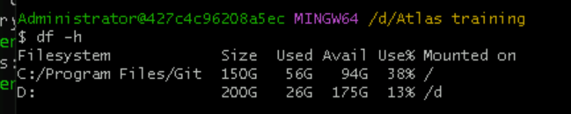

Task 24: Can you plz try using the below commands

|  |  |
| --- | --- |
| **Prefix** | **Description** |
| **-** | **Regular file**, such as an ASCII text file, binary executable, or hard link. |
| **b** | **Block special file**. Block input/output device file such as a physical hard drive. |
| **c** | **Character special file**. Raw input/output device file such as a physical hard drive. |
| **d** | **Directory** which contains a listing of other files and directories. |
| **l** | **Symbolic link file**. Links on any regular file. |
| **p** | **Named pipe**. A mechanism for interprocess communications. |
| **s** | **Socket** which is used for interprocess communication. |

Task 25: Find the list pf all files ending with .txt

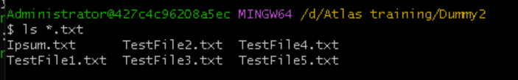

Task 26: In Linux all the hidden files starts with . (period)

How to check all the hidden files in Linux..

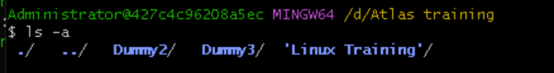

Hint : use  ls -a

Task 27: What is the difference between . and .. in linux

The single dot (.) is a meta-location, meaning the folder you are currently in. The double dot is an indicator that you can move back from this location. That is, you're in a folder inside of another folder. Once you start moving around within your computer, you can use that information for reference.

. Represent current directory

.. Represents parent directory

Task 28: Can you create a file using vi editor and show the details in ss

Hint:

 Esc is for come out of the edit mode

Press two keys Shift &plus; ZZ together to come out of the file completely

* I - to insert

To move inside the file

* **l** key to move to the right side.
* **h** key to move to the left side.
* **k** key to move upside in the file.
* **j** key to move downside in the file.

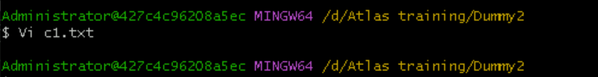

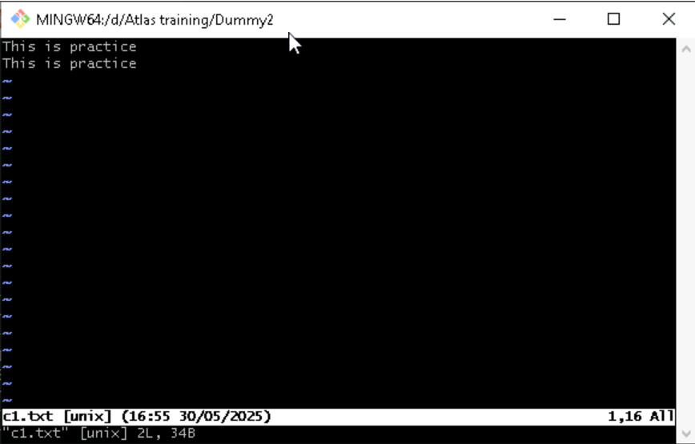

Task 29:

How to find the no of words in the file

Hint: use wc

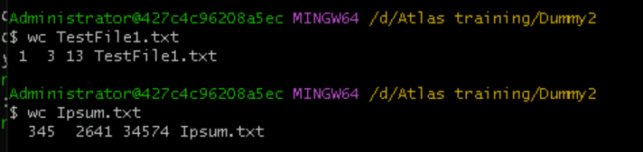

Here is the detail of all the four columns of wc command  −

* **First Column** − Represents the total number of lines in the file.
* **Second Column** − Represents the total number of words in the file.
* **Third Column** − Represents the total number of bytes in the file. This is the actual size of the file.
* **Fourth Column** − Represents the file name.

Task 30: What is the use of cat -b myfilename.txt command?

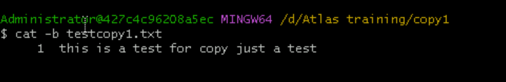

cat -b test1.txt : this command will give the output line by line with numbered format

Task 31:  Can I use the wc with 2 or more files?

Yes

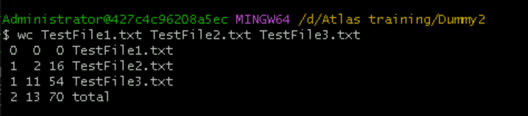

Task 32: How to copy content of one file to another file



Task 33: Now I want to rename my file with MYFILENEW can i do that if so how ?

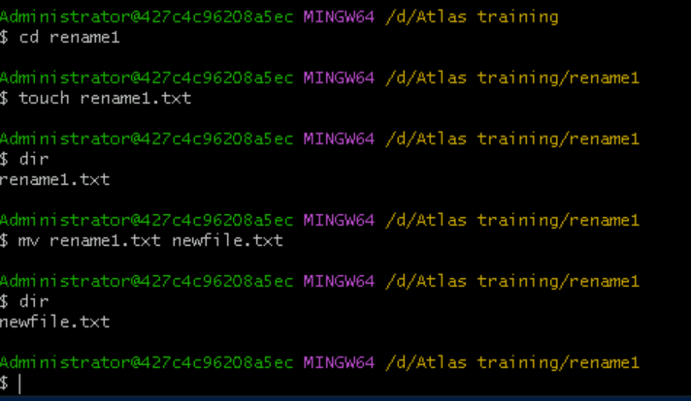

Task 34: Can i remove or delete multiple files in linux..? How?

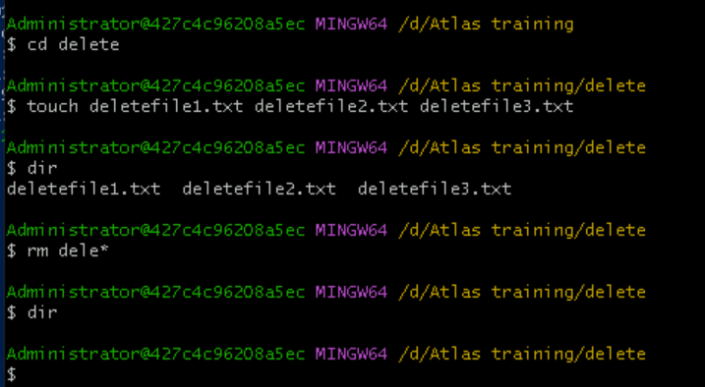

Task 35: In directory / slash is root  …  can you try cd / what is it doing?

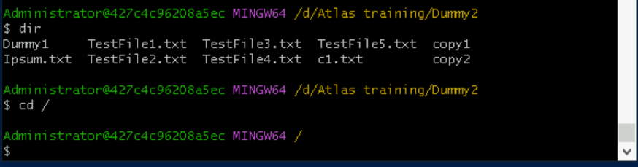

It takes us out of path we are in and takes us to home directory.

Linux directory structure: plz have a reading and try to remember..

|  |  |
| --- | --- |
| **Directory** | **Description** |
| **/bin** | important binary applications |
| **/boot** | boot configuration files, kernels, and other files needed at boot time. |
| **/dev** | System device files. |
| **/etc** | configuration files, startup scripts, etc. |
| **/home** | List of home directories for different users |
| **/lib** | system libraries, shared libraries |
| **/lost+found** | a lost+found system for files that exist under the root (/) directory |
| **/media** | automatically mounted (loaded) partitions on your hard drive and removable media such as CDs, digital cameras, etc. |
| **/mnt** | manually mounted filesystems on your hard drive |
| **/opt** | 3rd part applications to be installed |
| **/proc** | Maintains information about the state of the system, including currently running processes. |
| **/root** | root user's home directory. |
| **/sbin** | important system binaries |
| **/srv** | contain files that are served to other systems |
| **/sys** | system files |
| **/tmp** | temporary files |
| **/usr** | applications and files that are mostly available for all users to access |
| **/var** | variable files such as logs and databases |

Task 36: What is the way go go to home directory ?

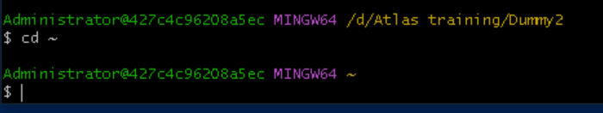

Task 37: If i want to move to different users home directory

